

**Product Person Name:** Siddharth Nautiyal

**POD Name:** Product Delivery - POD2

**Closing Date:** 23th April 2022

**Version:** 01

**Impacted Apps:** T&P CRM Panel

**KPIs (Key Performance Indicator):** To improve operational efficiency of Trainers

**User Stories**

* As a Trainer type user, I should be able to create dispositions for 1:1 Live Trainers Session
* As a Trainer type user, I should be able to create repetitive slots in Trainer Call
* As a trainer type user, I should be able to confirm and create 1:1 Live Sessions through CRM in trainers call
* As a trainer type user, I should be able to track the live 1:1 session in upcoming and recent tabs

**Feature Details**

As a Trainer type user, I should be able to create dispositions for 1:1 Live Trainers Session

**Steps**

1. CRM > Premium Users
2. Premium User (Trainer Type) > User Setting
3. User Setting > Disposition
4. In disposition there are multiple tabs available, in that we need add new tab

**\Detailed Description**

1. At present the disposition tab shows the following options

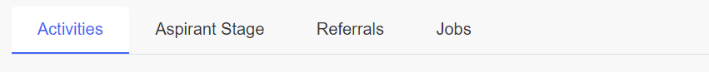

1. A new tab needs to be introduced in this, next to Activities Tab. The UI will show as following

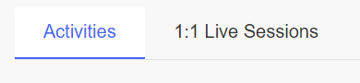

1. In 1:1 Live session the table will show as following

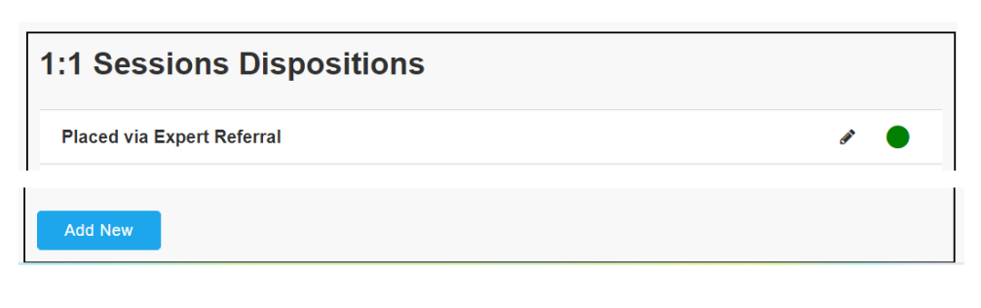

* 1. All the feature in the table will work as defined under “User Settings > Disposition > Activities Tab”
  2. The disposition added in these will reflect on the application side in the following manner

**Changes on the Application Side**

1. At present the trainer call card shows as following when clicked

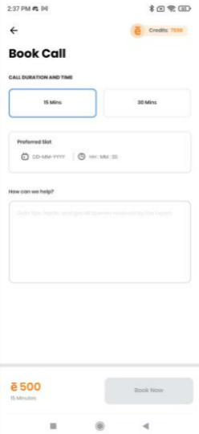

1. Now we will add to add a new dropdown field in the the schedule page

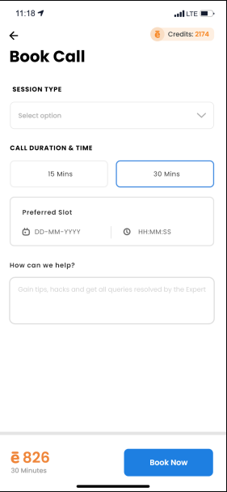

* 1. A new dropdown will be added above call duration
  2. The dropdown will have a header Session Type
  3. The dropdown user will able to select one session at a time
  4. The list will be populated from the backend. The data will come from 1:1 Live Sessions table in disposition
  5. This will only add disposition which are in active bucket
  6. Once the session is selected and aspirant has clicked book now, the fields will be captured and shown in trainers call

1. Changes in Calling card UI shown once the session has been accepted. At present we only have cards for live sessions which are shown on the application side.

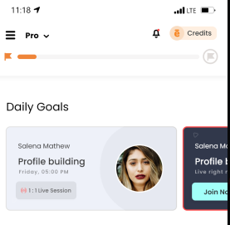

1. In the card show, all the fields will be same shown in live session, just the session description in the left right corner will show as “1:1 Live Session”

**Acceptance Criteria**

1. When a session is requested by an aspirant, an in app notification telling - “Your 1:1 Live session request has been shared with <Trainer Name>”
2. When Session is accepted by the trainer by clicking Confirm on the backend in the CRM, the following notification will come - “Your 1:1 Live Session request has been accepted by <Trainer Name>”
3. When Session is declined by the trainer by clicking Decline on the backend in CRM, the following notification will come - “Your 1:1 Live Session request has been denied by <Trainer Name>, all the credits have been refunded”
   1. Credits refunded should reflect in overall credits shown in application for an aspirant
4. When session is accepted, in app notification will be triggered in gap of 15 minutes, 1 hour before the session
   1. “Your 1:1 Live session with <Trainer Name> is scheduled for today at <Time of session>. Please join the session on time.”

**Feature Details**

As a Trainer type user, I should be able to create repetitive slots in Trainer Call

**Steps**

1. CRM > Premium Users
2. Premium User (Trainer Type) > Trainers Call
3. When user clicks on trainers call set preference windows shows

**Detailed Description**

1. At present the trainers call is an audio call feature which will now be updated to incorporate video calls only. At present the trainers call shows as follows

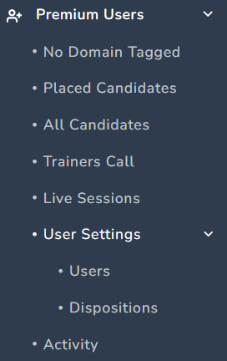

1. The name of the Trainer Call needs to be updated to 1:1 Live Sesion, and it will show as the following

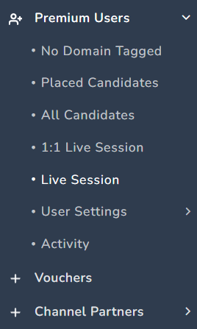

1. When a user clicks on Trainers Call the following window appears

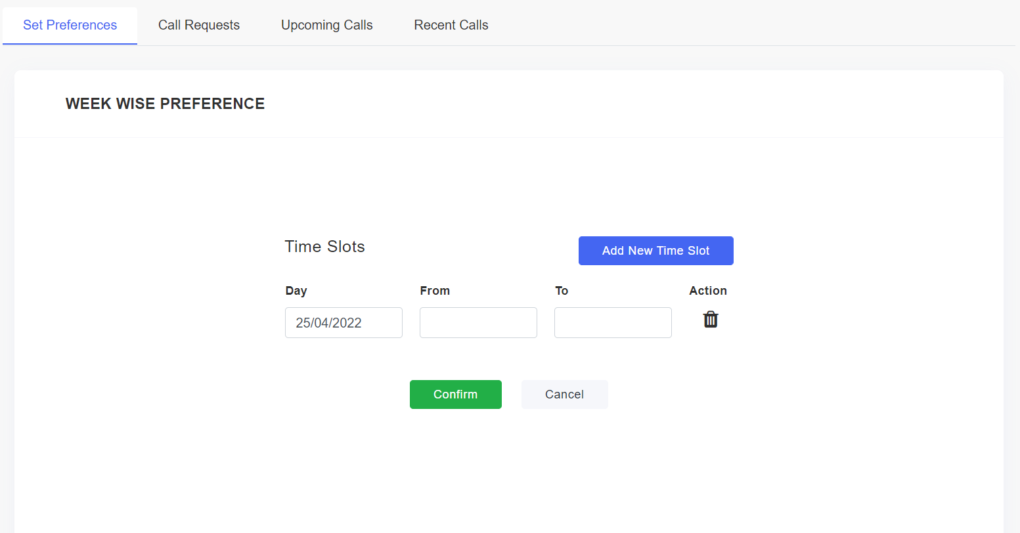

**Changes To be made in Set Preferences Tab**

1. At present there is no functionality to make sessions repetitive.
2. So, corresponding to delete button against each time slot a Repeat Weekly will also be available in the following manner

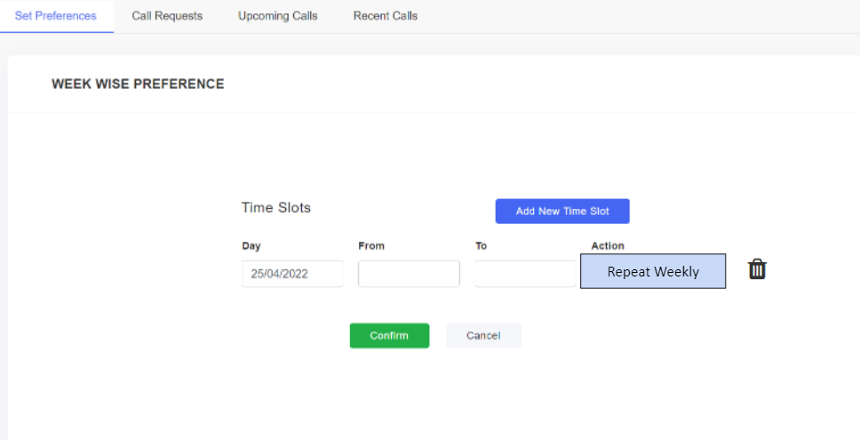

1. The repeat weekly option will be available corresponding to each time slot. If the user clicks on Repeat Weekly
   1. For the weekday and the time for which the time slot is set will be same for the next week too, and so on and so forth
   2. Same will be reflected to aspirants requesting for 1:1 live sessions through the application
   3. If Repeat weekly is not selected for a slot, the slot will show as it presently does

**Acceptance Criteria**

1. All the feature in the set preference tab will function as they use to
2. The selected time slots will become repetitive only if user clicks confirm
3. Also, the repetitive time slots will also reflect on the application side
4. Live session to be renamed as - “Live Group Session”

**Feature Details**

As a trainer type user, I should be able to confirm and create 1:1 Live Sessions through CRM in trainers call

**Steps**

1. CRM > Premium Users
2. Premium User (Trainer Type) > Trainers Call
3. When a user clicks there is Call Request window available

**Detailed Description**

1. At present in the call request the table shows the following options. Where in Description is the new column introduced

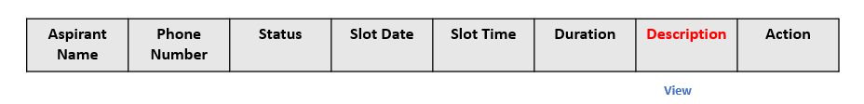

1. Now we need to add another column in the following manner



* 1. Session Name is a new column
     1. It is a dynamic field which will be updated as per session selection done by aspirant in application

1. If a user clicks on “Confirm” popup will show in the following manner

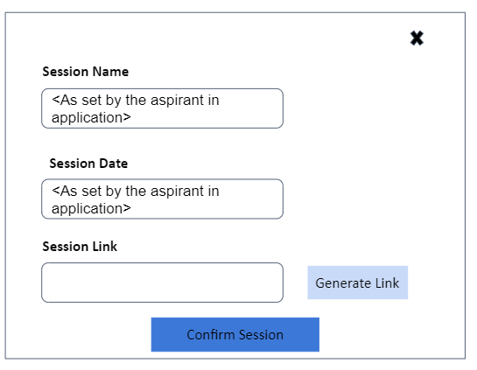

* 1. The popup will show the following information
     1. Session Name - Dynamic field as set by the aspirant while raising request from the application
     2. Session Date - Dynamic field as set by the aspirant while raising request from the application
     3. Session Link - It’s a editable field where user can enter meet link manually
        1. By Clicking Generate Link - User will be able to create dynamic session link and same will be shown in Session Link field
           1. Generate Link - This feature will be integrated with google meet, which allows users to create unique links when the user clicks on the Generate Link.
        2. It is a mandatory field and follow validations as followed while adding Google Meet while creating live sessions
     4. Confirm Session - When a user clicks on the Confirm session
        1. The Session will move to upcoming sessions tab
        2. A live session will be created and shown in the application of the tagged aspirant who requested the session. This card will be the same as a live sessions card created for the aspirants on application side.

**Acceptance Criteria**

1. The call request session needs to be renamed as “1:1 Session Request”
2. If a call request is declined then the credits will be refund to the aspirant
3. The mail will be triggered to the aspirant and the trainer regarding cancellation of the session

**Feature Details**

As a trainer type user, I should be able to track the live 1:1 session in upcoming and recent tabs

**Steps**

1. CRM > Premium Users
2. Premium User (Trainer Type) > Trainers Call
3. When a user clicks there the Call Request, Upcoming Call, Recent Calls windoware are available

**Detailed Description**

1. At present the when user clicks on trainers call following option are seen



1. These needs to be renamed as following manner



**Changes in Upcoming Calls**

1. At present the upcoming section shown the following information

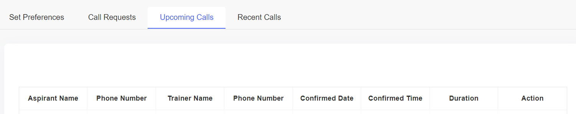

1. As, we have updated the feature for conduction live calls, the Upcoming Calls window will be updated in the following format

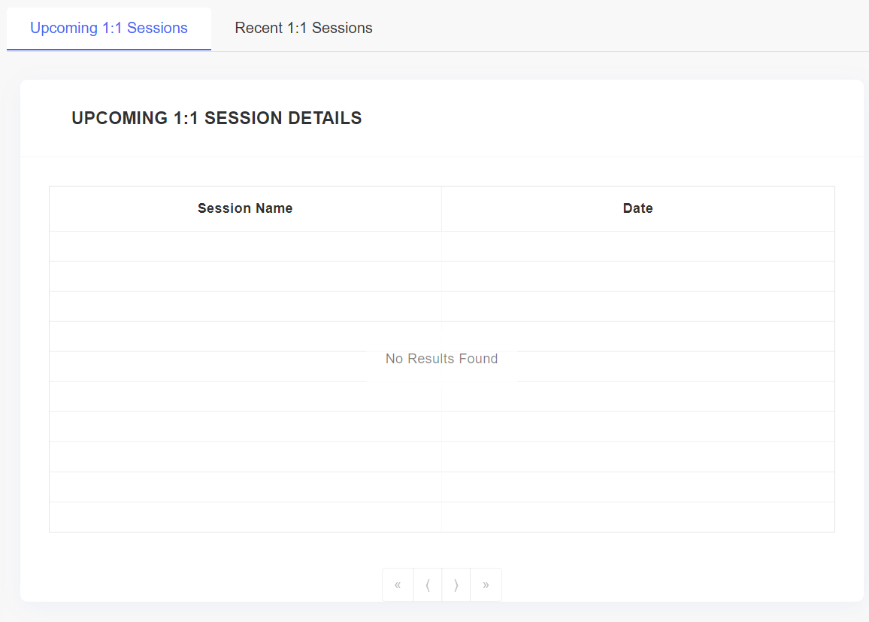

* 1. This Tab will function as defined under Live Sessions > Upcoming Live Sessions

**Changes in Recent Calls**

1. At present the upcoming section shown the following information

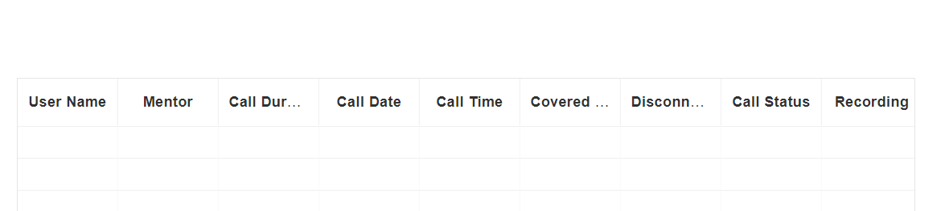

1. As, we have updated the feature for conduction live calls, the Recent Calls window will be updated in the following format

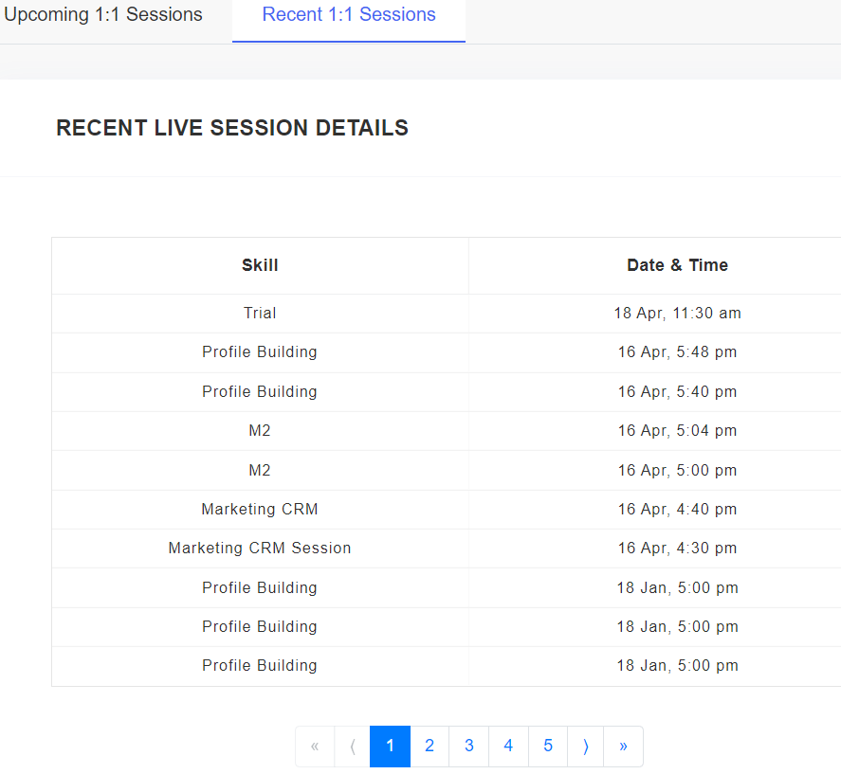

* 1. This Tab will function as defined under Live Sessions > Recent Live Sessions

**Acceptance Criteria**

1. The session will be tracked in track activities
2. The 1:1 session will also be shown in profile of the aspirant as it does for Live Session
3. Trainer should be able to cancel the session.There